**Name**: Abdullah Emad Ibrahim

**B.N: 12**

**Sec.22**

**Gr.4**

**Date: 6/6/2021**

# **Topic:** **Operating system .**

# **Application Brief:**

**hello**

**I chose this topic cus I know about it a lot and dell with Linux, Windows, and Linux**

**So on my website, I insert tables, images, links, and lists ordered and unordered I hope**

**I could cover this important topic as well as possible.**

# **Screenshots:**

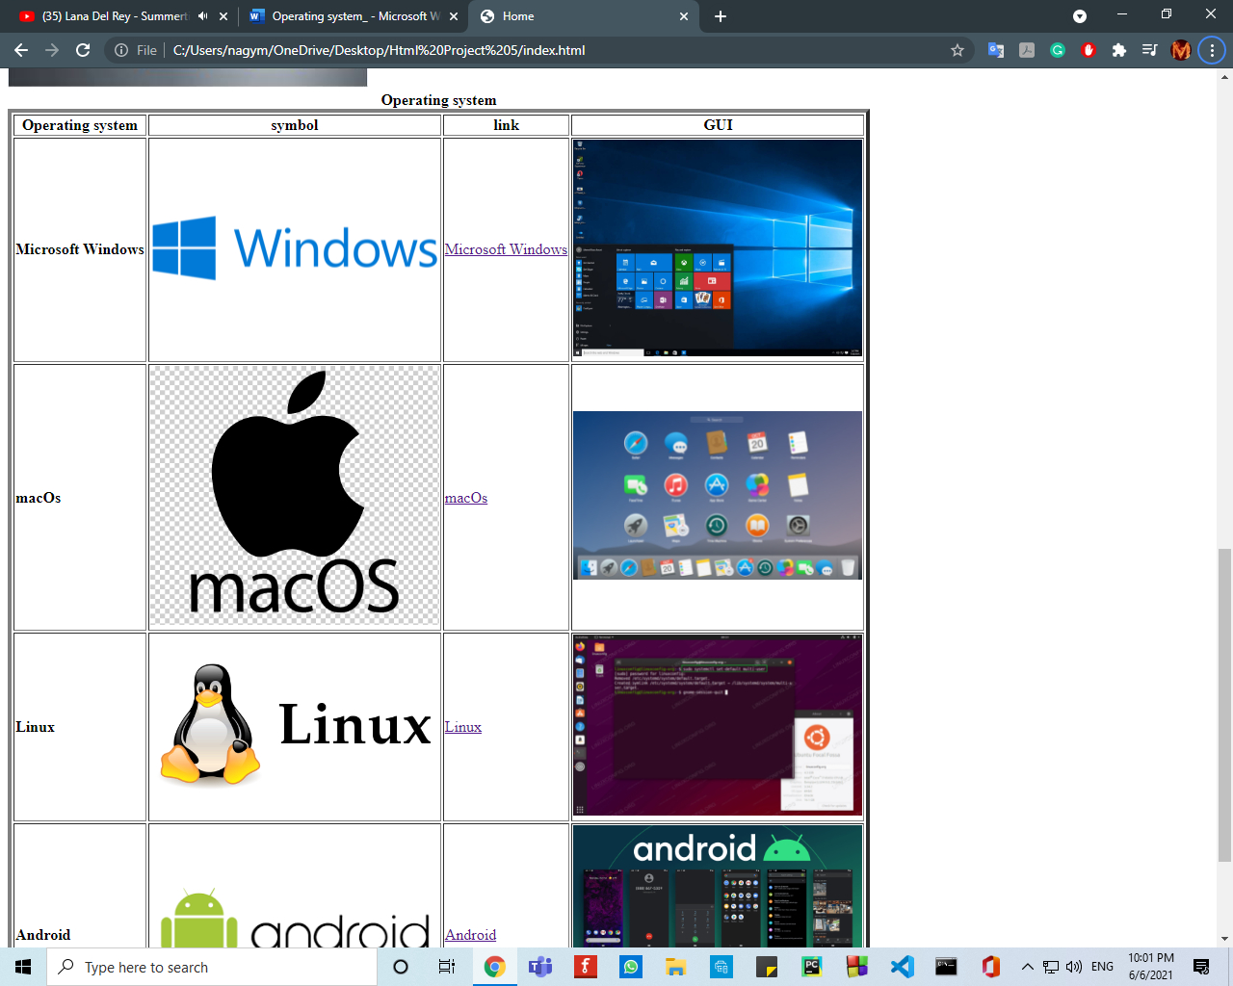

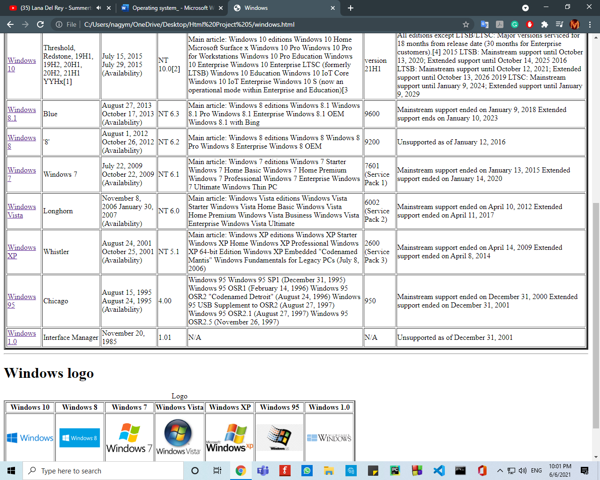

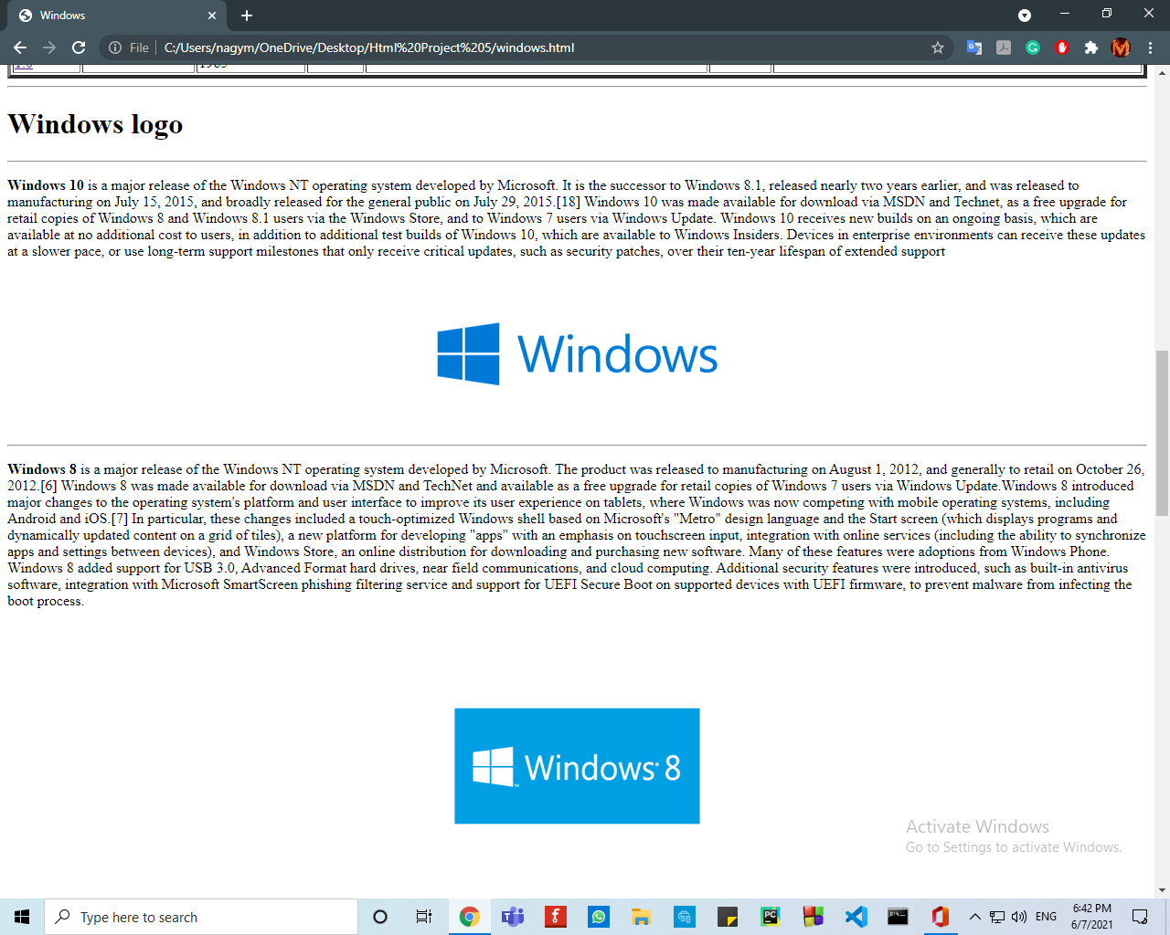

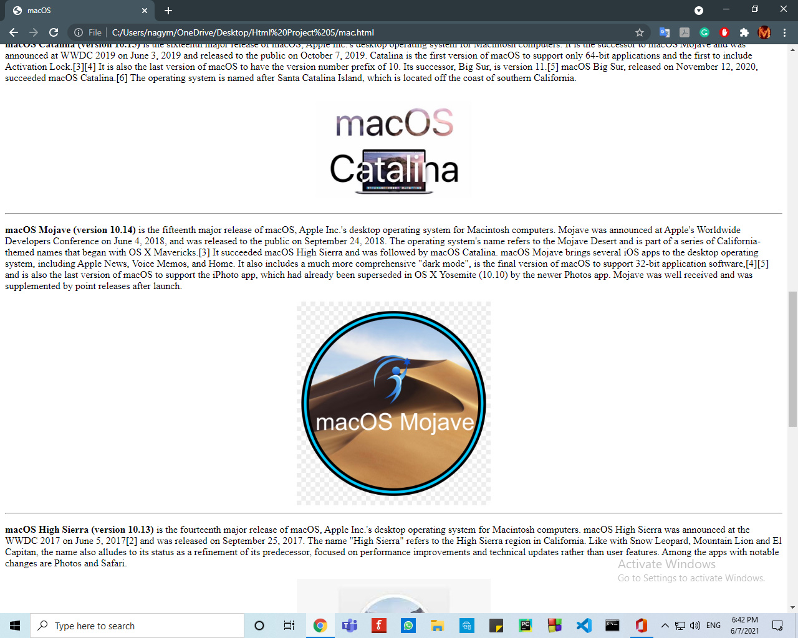

# **Source Code:**

